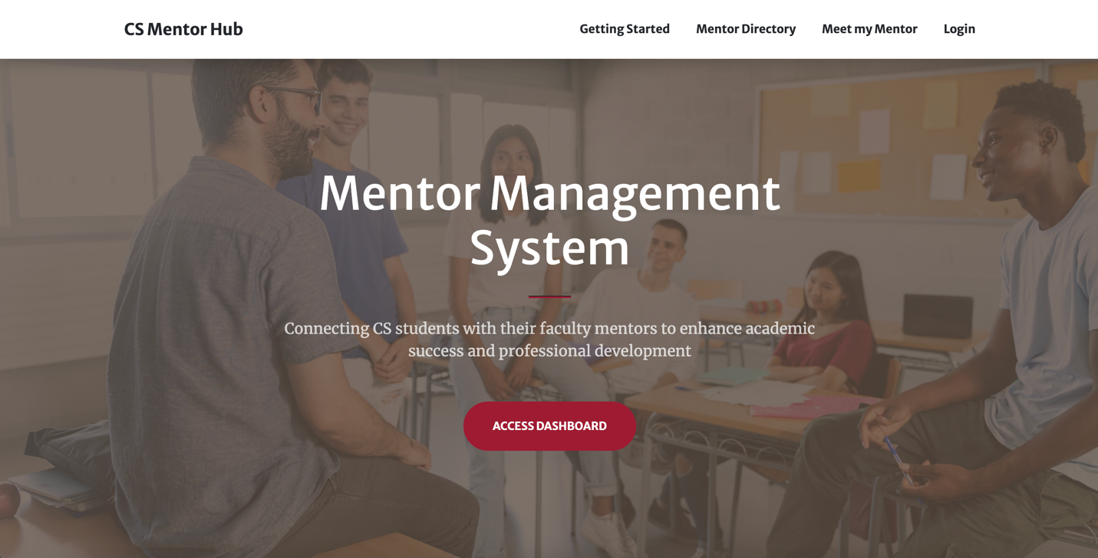
Sprint Planning Document (Sprint 1)
Sprint Goal Backlog (Sprint 1)
January 23 - February 18, 2025
{Andy Hahn, Hannah Hazelwood, Gregory Nothnagel, Manjila Singh}

High-level Project Overview

Project Mission:
- The Mentor Management Project aims to support a mentorship program for freshmen in the Computer Science Department. Through this program, students can receive academic, professional, and personal development.

Problems We Are Solving:
- There is currently no infrastructure for a mentorship program.
- Materials and information are decentralized, causing a lot of extra work to manually send emails and review form responses.
- There are many students in the department compared to the number of faculty. This means there is a large time burden on those facilitating the mentorship program.
- Freshmen struggle to adjust to college life and need extra support.

Project Overview (High-Level Features):
- Mentor Management Website:
  - Sign-in/up: Users should be able to sign in with crimson email address to Microsoft.
  - Meet My Mentor: Page should display a student’s mentor and all necessary information about that mentor.
  - Mentor Directory: Users should be able to see a list of all mentors. Students can request to change their mentor.
  - Home Page: Home-screen is a landing page with basic information about the application and its features.
  - Get Started: This page should give basic instructions to students about the mentorship process.
  - Interest Forms: Students should be able to fill out a form with various information about themselves before a meeting. Mentors should be able to see the form responses that their mentees have provided.
  - Logging a Meeting: After a meeting, a mentor should be able to add a log for the meeting to track it.
  - Meeting Scheduler: A student should be able to schedule a meeting with their mentor. Both students and mentors should be able to see all of their upcoming mentorship meetings.
  - Tracking Students: Users should be able to track a student from freshman to senior year. A student should be able to see their meeting history. A mentor should be able to see all of their students’ meeting histories. An admin should be able to see all the students’ meeting histories.
- Admin Dashboard
  - CRUD Dashboard for admin and student workers to manage students, mentors and mentorships.
- Backend Services
  - Realtime Database: Data for students, mentors, mentorships, meetings, interest forms etc.
  - Hosting: Host the web app on the cloud. Should be able to deploy and run the project through Docker.
  - Authentication: Use OAuth to connect to Microsoft (crimson emails) for authentication.

Sprint 1 Planning
Sprint 1 Goals:
- Research the tools to be used in this project.
- Create a basic frontend and backend.
- Deploy and run the service through Docker.
- Create the database and populate it with sample data.
- Allow a user to sign in with Microsoft using OAuth.
- Allow a student to see their mentor along with information about their mentor.
- Create a view for a mentor to see a list of their mentees/students.
- Create draft of project website.

Sprint 1 Deliverables:
- Research the tools to be used in this project:
  - Assigned: {Hannah Hazelwood, Manjila Singh, Andy Hahn, Gregory Nothnagel}
  - Research and read through all of the necessary documentation for the tools to be used throughout the project. Discover which tech stack we will need to use.
- Setup the basic frontend and backend:
  - Assigned: {Manjila Singh, Andy Hahn}
  - Setup a basic backend with the Django framework.
  - Create a basic frontend with node.js using express.js.
- Deploy and run the service through Docker:
  - Assigned: {Andy Hahn, Gregory Nothnagel, Manjila Singh, Hannah Hazelwood}
  - Create all necessary files needed to run the frontend, backend, and database with a docker-compose command.
  - Ensure README has up to date information on how to run the application using Docker.
- Create the database and populate it with sample data
  - Assigned: {Hannah Hazelwood, Andy Hahn, Gregory Nothnagel}
  - Use postgreSQL to create the database for the application.
  - Connect this database to the Django Admin Dashboard
  - Create all necessary tables in the projects init.sql file to initialize the database during the build of the Docker container. Tables include students, mentors, mentorships, meetings, and interest forms.
  - Populate the database with some sample data in the init.sql file for testing purposes.
- Allow a user to sign in with Microsoft using OAuth.
  - Assigned: {Gregory Nothnagel, Manjila Singh}
  - Investigate how OAuth can be used for the login feature.
  - Allow students to log into the application with their crimson email, connecting our application to Microsoft.
- Allow a student to see their mentor along with information about their mentor
  - Assigned: {Andy Hahn, Manjila Singh, Hannah Hazelwood}
  - Query the database to show an individual student their mentor match.
  - Create the Meet my Mentor Page. This page should showcase information about the mentor, including office hours, contact information, and research interests.
  - Connect to login feature to pull the current logged in student and automatically show the correct mentor.
- Create a view for a mentor to see a list of their mentees/students
  - Assigned: {Andy Hahn, Manjila Singh, Hannah Hazelwood, Gregory Nothnagel}
  - Query the database to pull all mentees that have a mentorship relationship with a mentor.
  - Create a page to show a list of students.
  - Connect to login feature to pull the current mentor to automatically get the correct list of students.
  - Add roles or a separate view to differentiate a mentor and student as two different users. A student should not see the option to see all mentees and a mentor should not see an option to meet their mentor. This will require some roles being assigned to users.
- Create Project Website
  - Assigned: {Hannah Hazelwood}
  - Create the first draft of the project website. Include a page for the main goals of the project, an about page for the team, and a page for all sprint deliverables.
  - Host the website with GitHub pages.
  - Update the Project Website with information as sprint deliverables are completed.

